Problem Statement

In the previous project, the automated questionnaire eliminated paper-based application and improved processing time up to 50%. It also provided an output csv file that can be used as input for other banking systems. Client experience was also improved as the automated tool can be deployed as an online system and can have a straightforward experience to determine his investment risk assessment (Conservative, Moderate, Aggressive).

However, for the financial advisor, providing more investment insights to the client to make better investment decisions would need to rely on the advisor’s own experience and lead to bias recommendations, thus the need for data analytical support in the form of machine learning predictions.

Having access to predictions based from statistical datasets will provide insights and informed data-driven decisions. This project would address the problem through the following goals:

- Provide a facility to perform investment risk assessment analysis based from a dataset.
- Predict the risk assessment based from client information and existing dataset information.

Define Data Requirements/ Data Gathering

Information needed for risk profile assessment related to the automated questionnaire are as follows:
- Demographics
- Income
- Financial Knowledge
- Employment Status
- Household Structure
- Expectations

Data Collection and Data Sources

The dataset shall be extracted from USA Survey of Consumer Finances, containing information on balance sheets, pensions, income, and demographic characteristics. It contains the dependent variables needed to train and predict the investment risk assessment.

Data Exploration and Preliminary Analysis

- There are 22,795 rows and 357 columns.
- There are duplicate rows in terms of the ID.
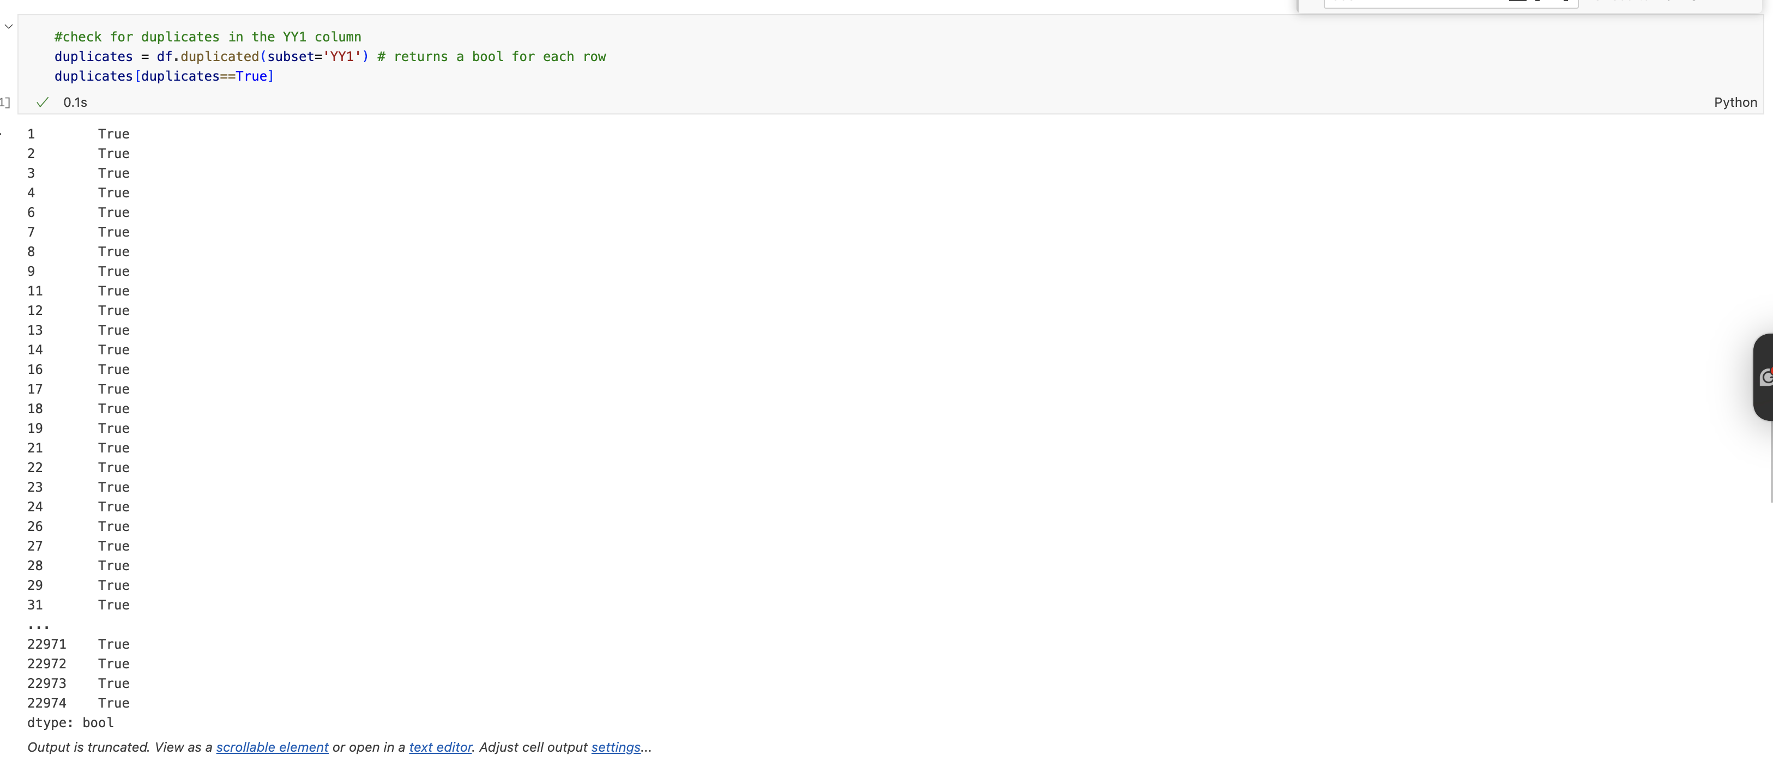
  - Based from the source: Missing data in the survey have been imputed five times using a multiple imputation technique. The information is stored in five separate imputation replicates (implicates). Thus, for the 4,602 families interviewed for the survey, there are 23,010 records in the data set. Seven observations were deleted for the public version of the data set for purposes of disclosure avoidance; thus, there are 22,975 records in the public data set for 4,595 families. The codebook provides more detail on the structure of the data set and the steps taken for disclosure avoidance.
  - Handling: For continuous variables, mean shall be used. For discrete, mode shall be used.
- There are no missing values in the dataset.
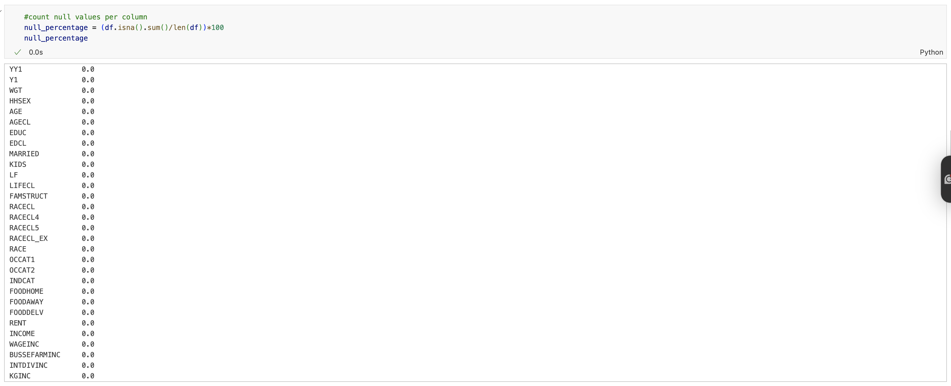
Correlation observations
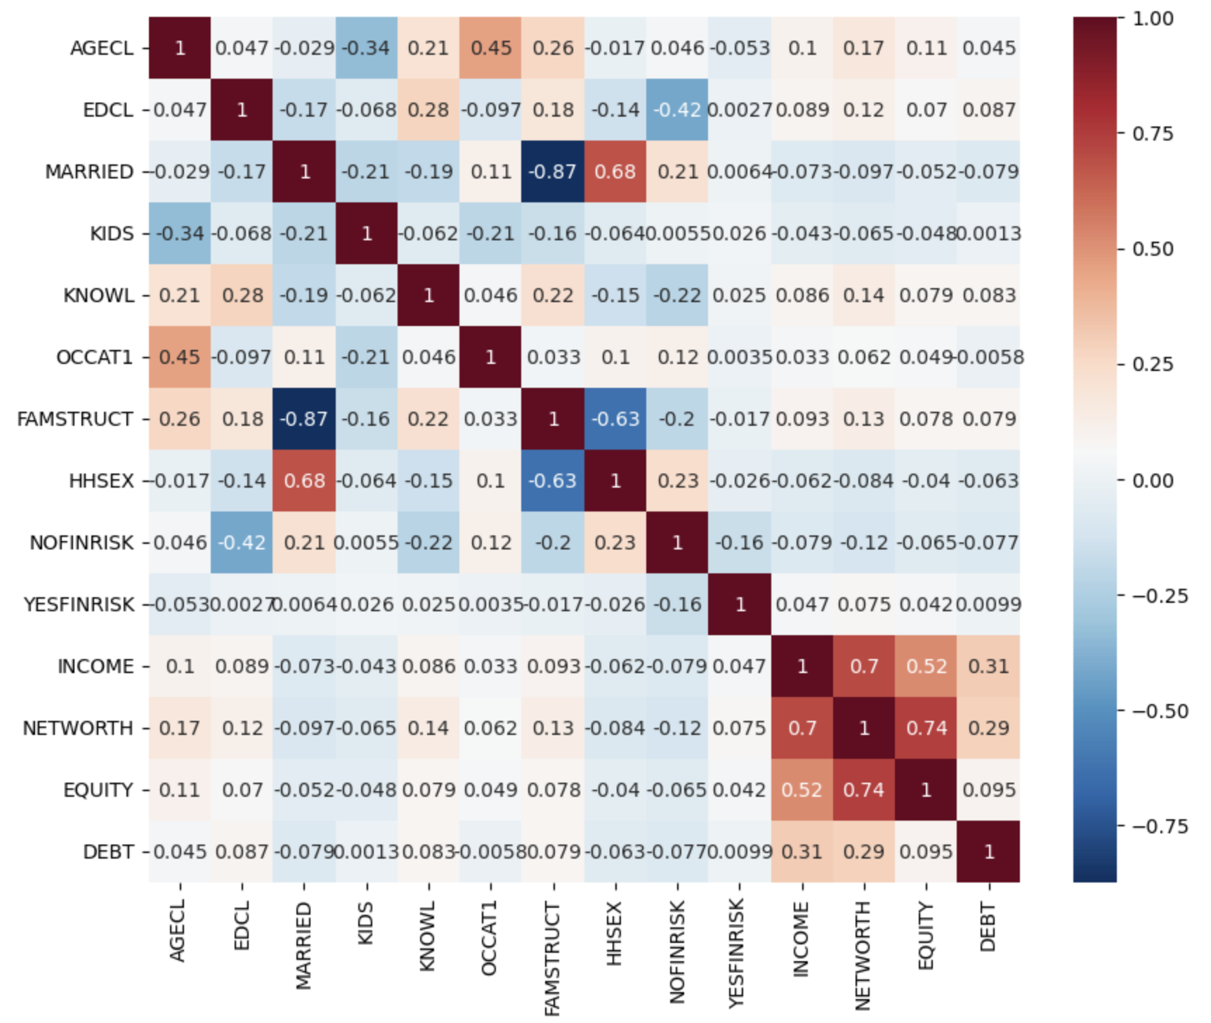
Correlation Table

- NETWORTH and INCOME have a strong correlation, which can signify that higher income may result to more investments, increasing net worth.
- NETWORTH and EQUITY also have a strong correlation, which can signify that higher net worth can have more stock holdings and can mean an aggressive risk appetite.
- DEBT has a moderate correlation with INCOME and NETWORTH, where it can signify that investments may be done in the form of mortgages to increase asset value.
- EDCL (Education Classification) has a minor negative correlation with NOFINRISK (No Financial Risk) wherein as the education level increases, the less likely the client will be conservative.
- KNOWL (Financial Knowledge) has a minor negative correlation with NOFINRISK, wherein as the financial knowledge increases, the less likely the client will be conservative.
- OCCAT1 (Occupational Category) has a positive correlation with AGECL (Age Class) and EDCL (Education Class) wherein an older and educationally achieved client most likely have a higher position, which can have higher income and networth.

Define Tools and Technologies
- Dev Tool : VS Code
- Programming Language: Python
- Libraries:
  - NumPy – for numerical computation
  - Pandas – for dataframe manipulation/ data cleaning
  - Matplotlib – for visualization
  - Seaborn – for visualization
  - Sklearn – for model training/ advanced analytics
  - Streamlit – for web tools
- Model: The model is designed to be running in a web browser and can be accessed online.

